**Task 1**

1. **NETWORKING AND SECURITY**

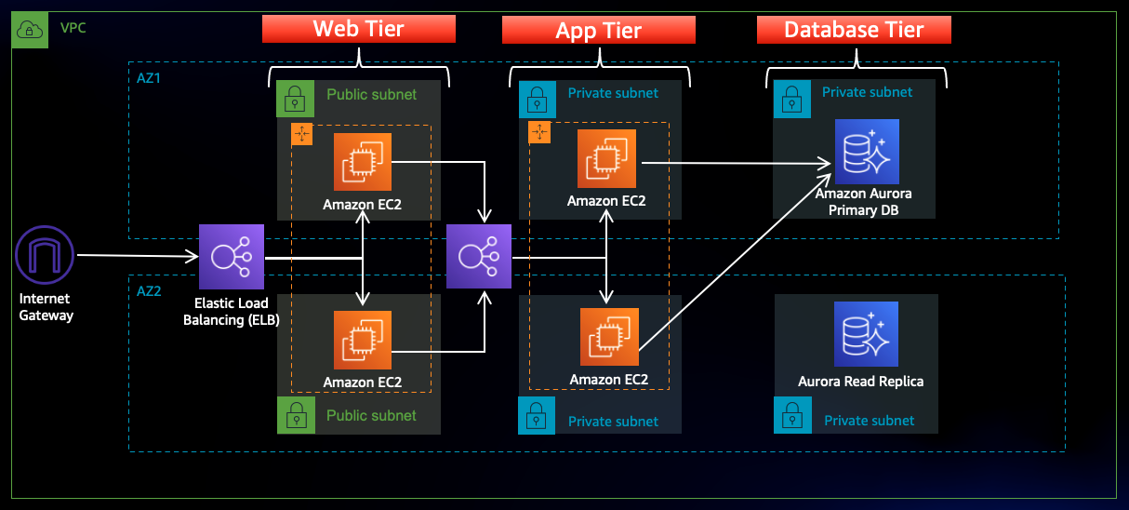

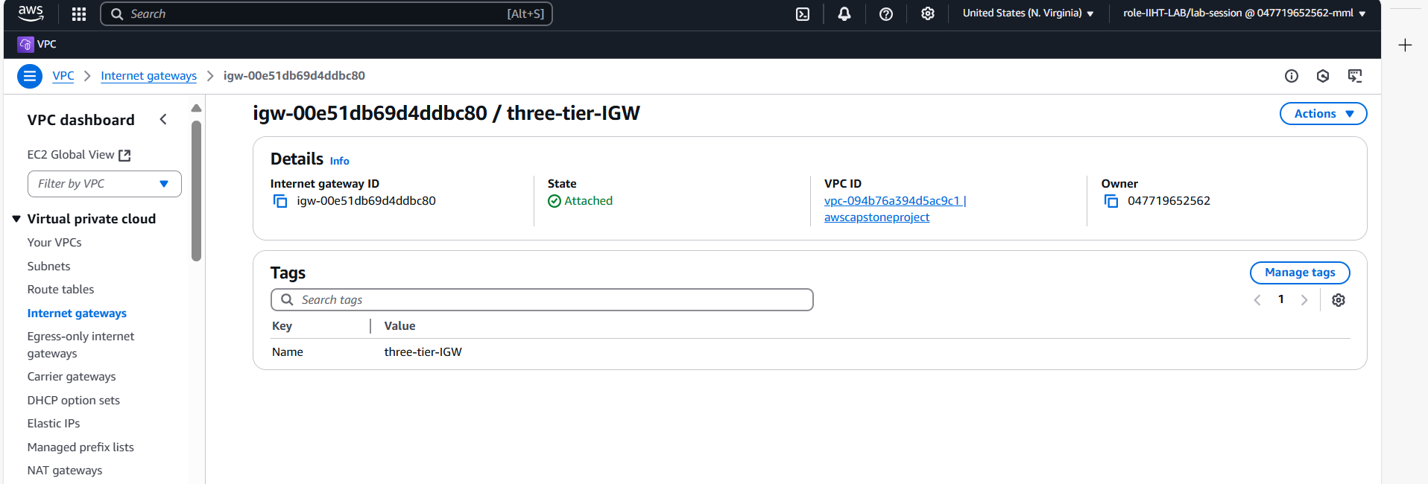

**Step 7: Create two NAT Gateways to both the Public-Web-Subnet-AZ1 and Public-Web-Subnet-AZ2**

Name: NAT-GW-AZ1 and

Name: NAT-GW-AZ2

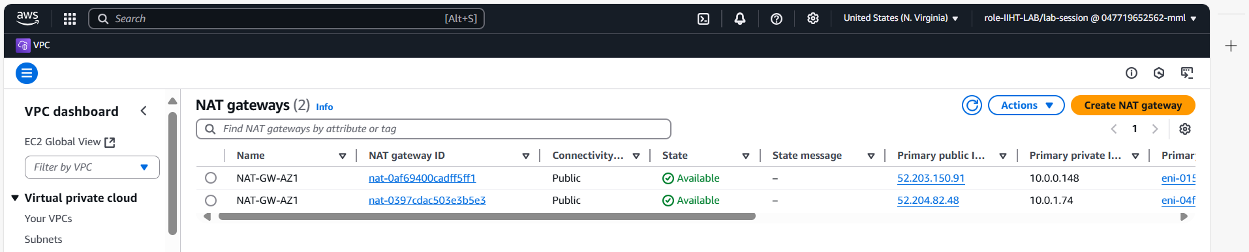

**Step 8: Create a Route Table**

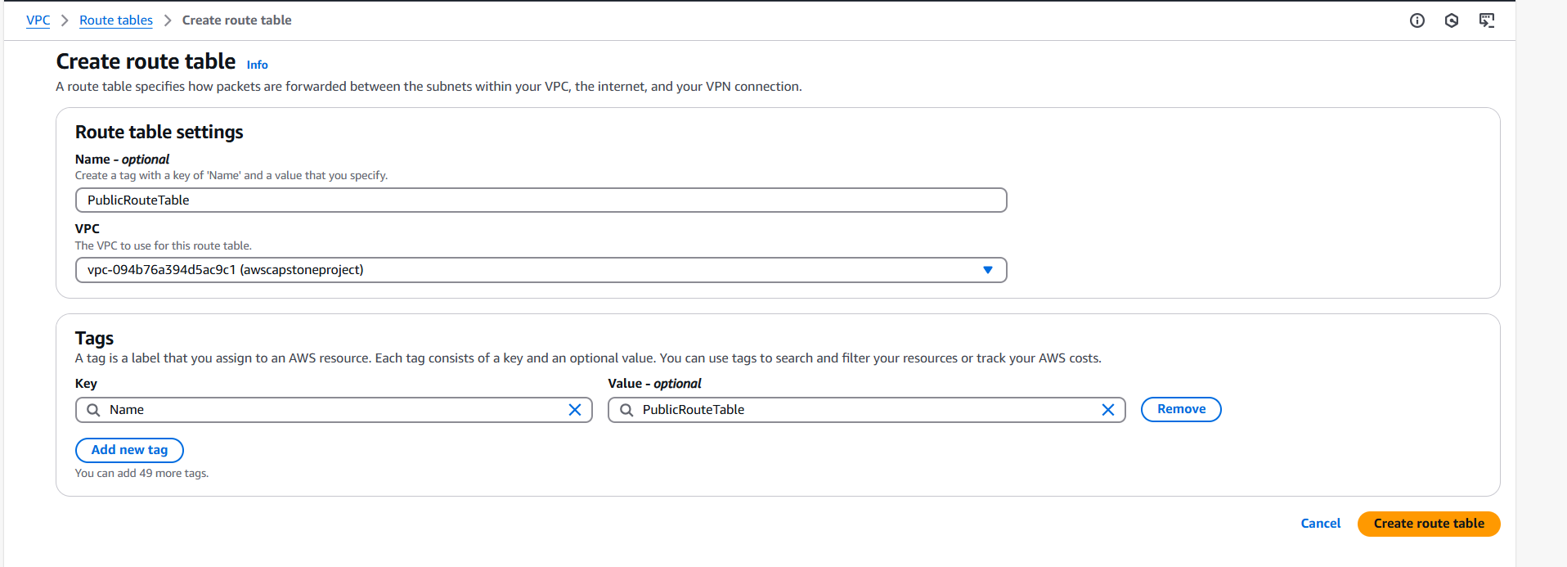

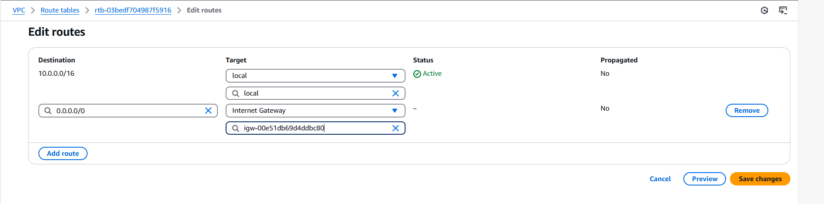

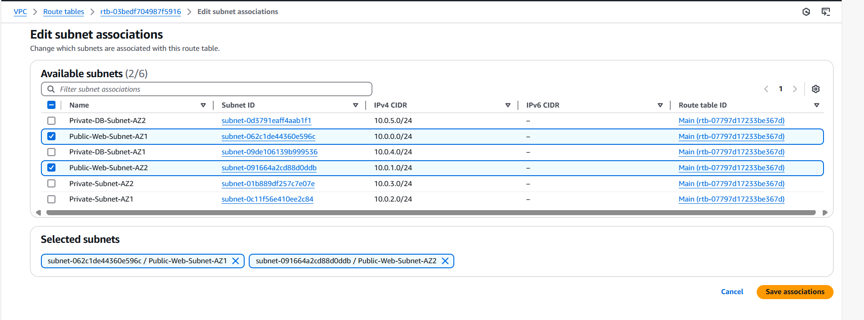

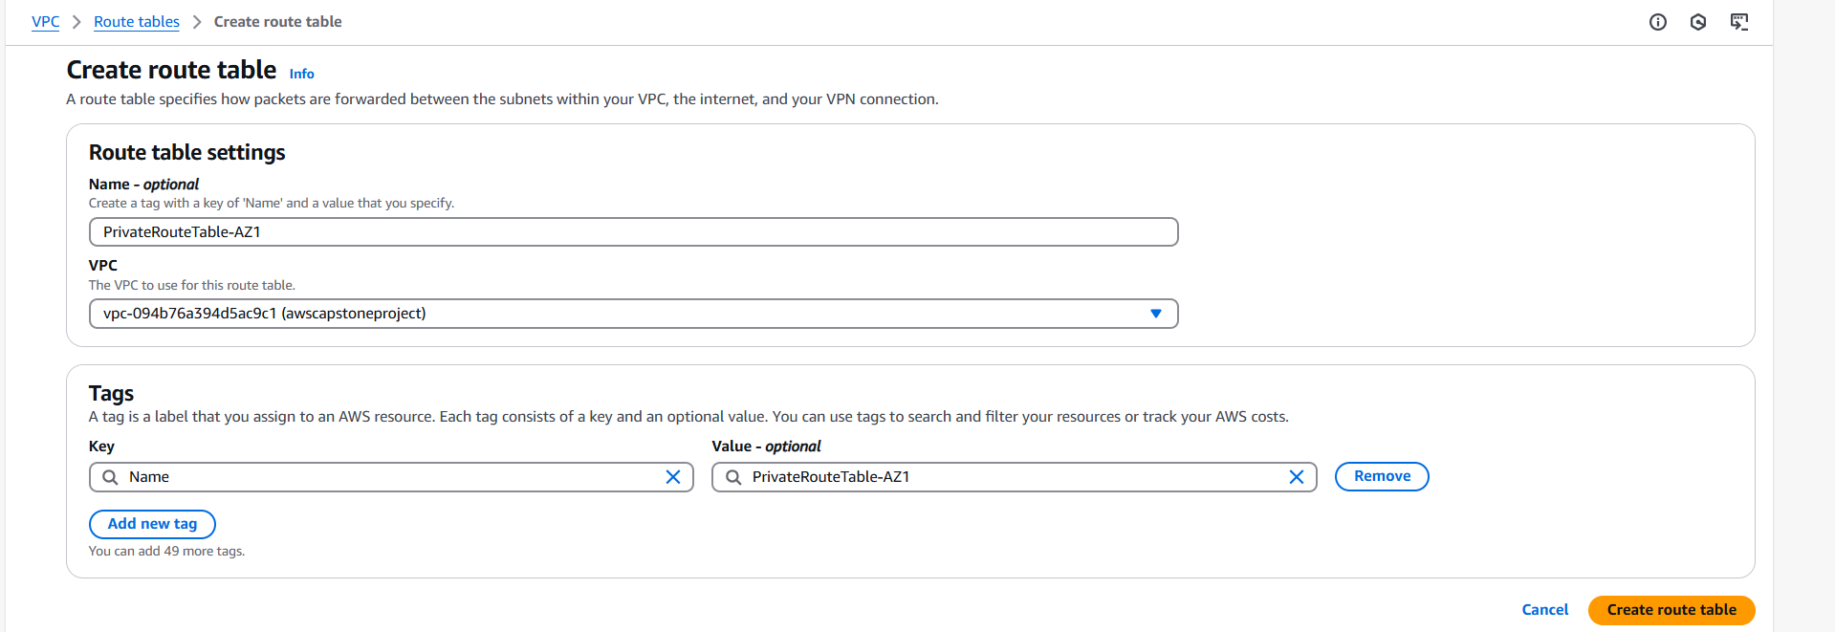

Creating NAT Gateway for the private subnet instead of internet gateway what we did in public subnet is internet gateway.

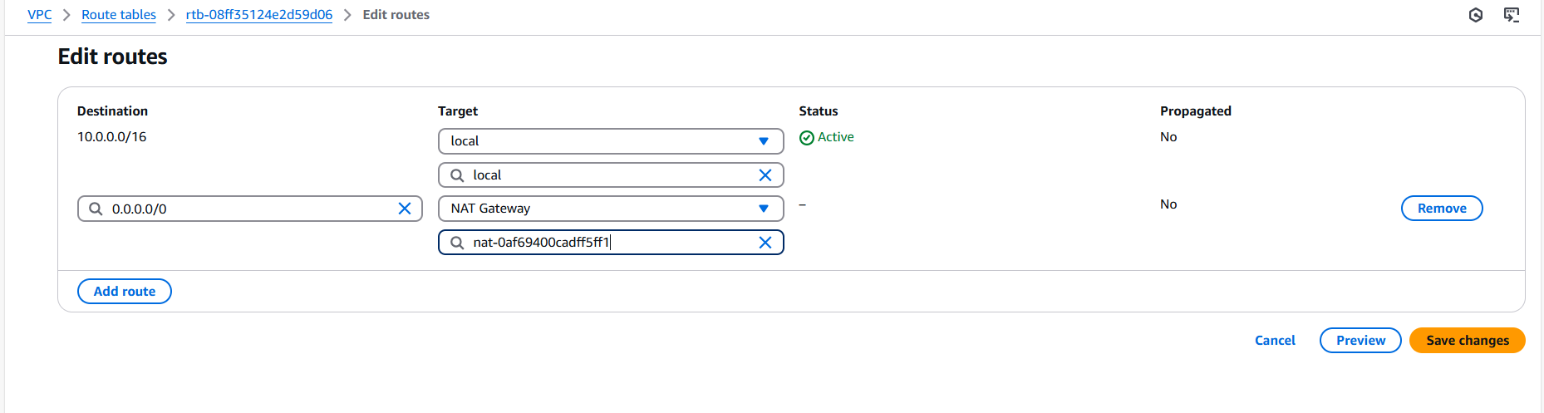

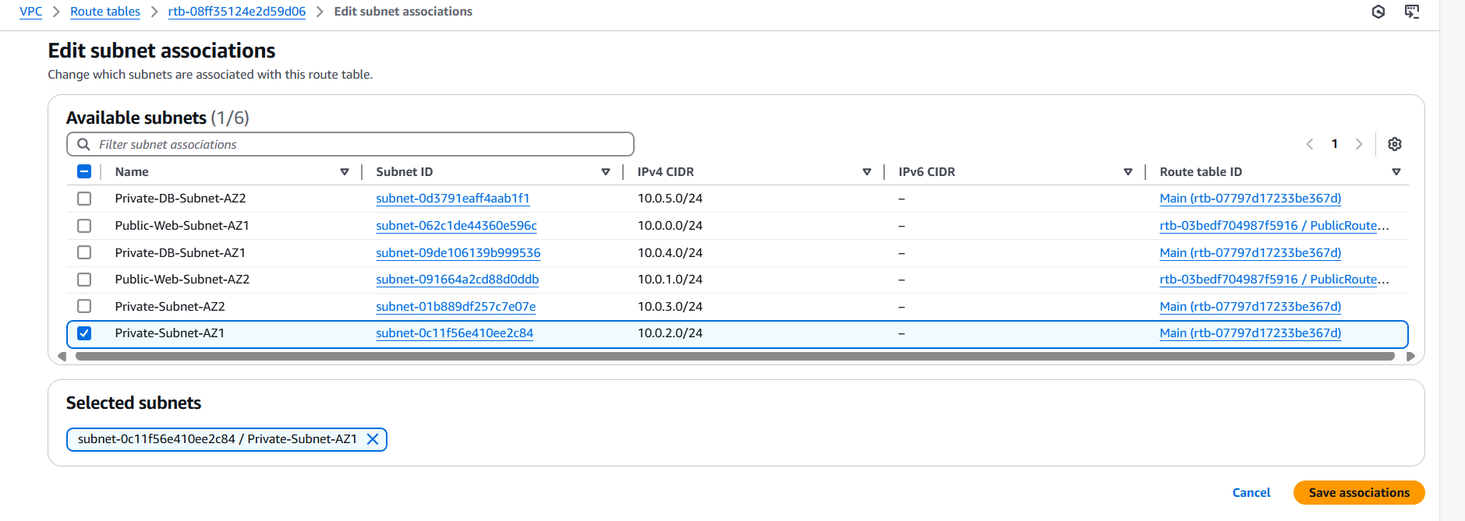

**Step 9: Creating a security group**

Name: InternetFacing-lb-sg

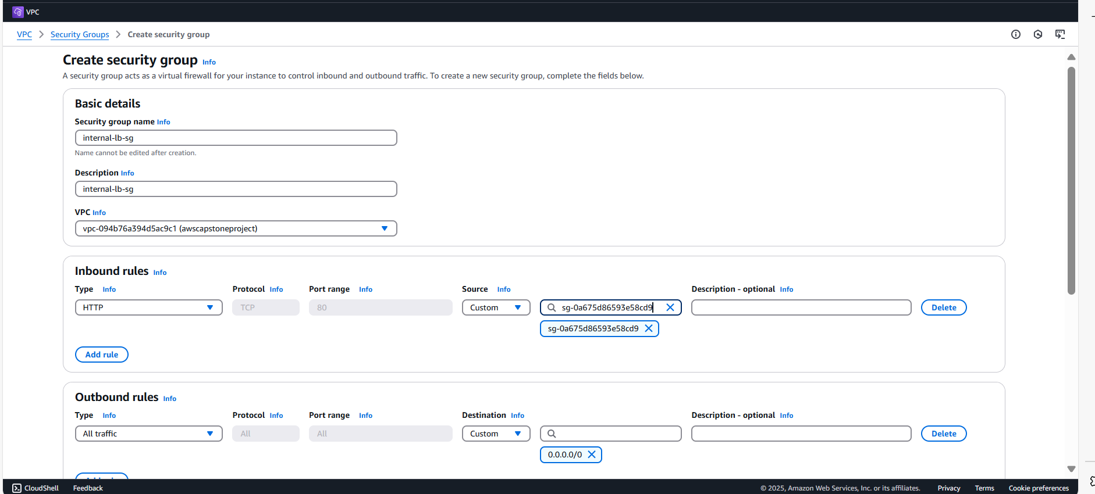

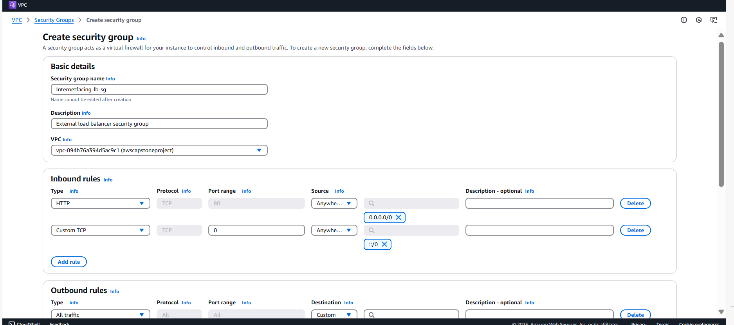

Create another security group

Name:WebTier-sg

3rd security group for accessing the internet within the web tier.

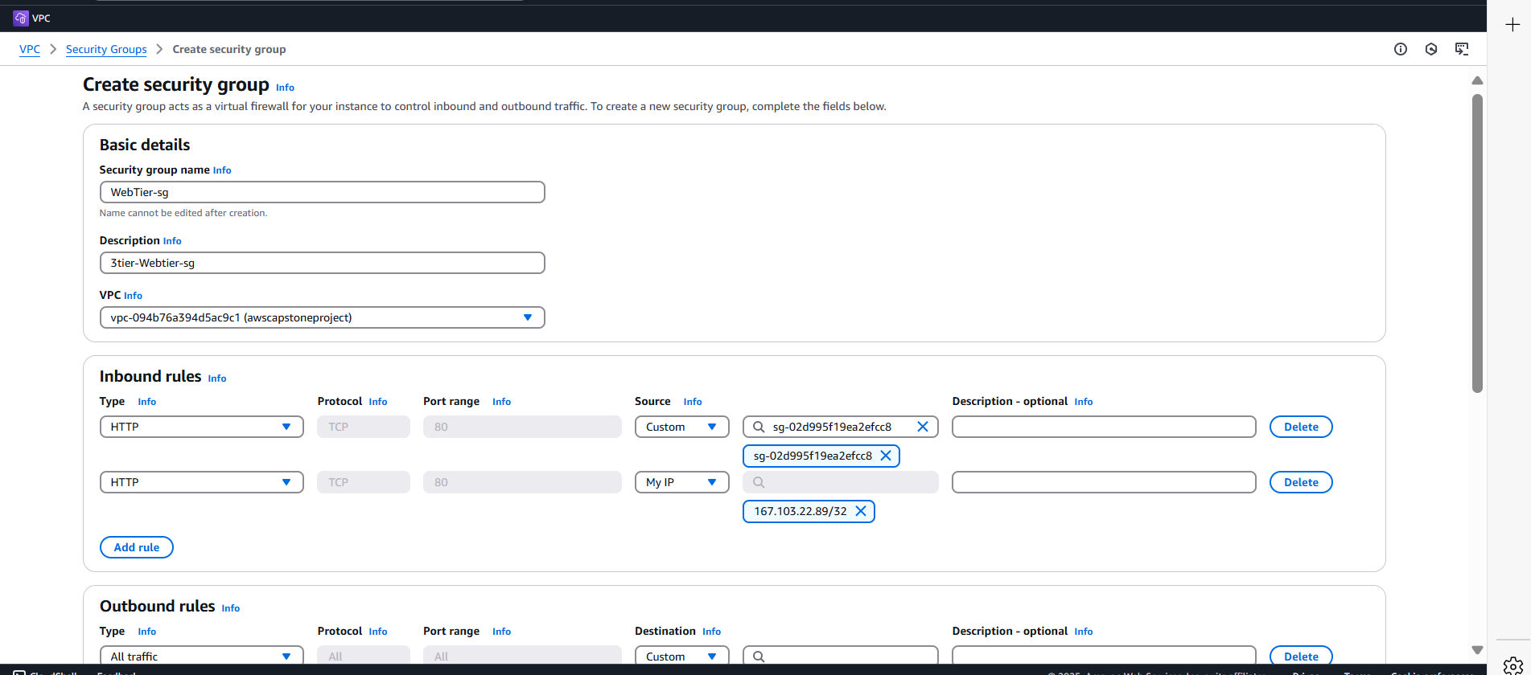

4th security group is for the private servers.

Open port: 4000

Security group:Internal-lb-sg

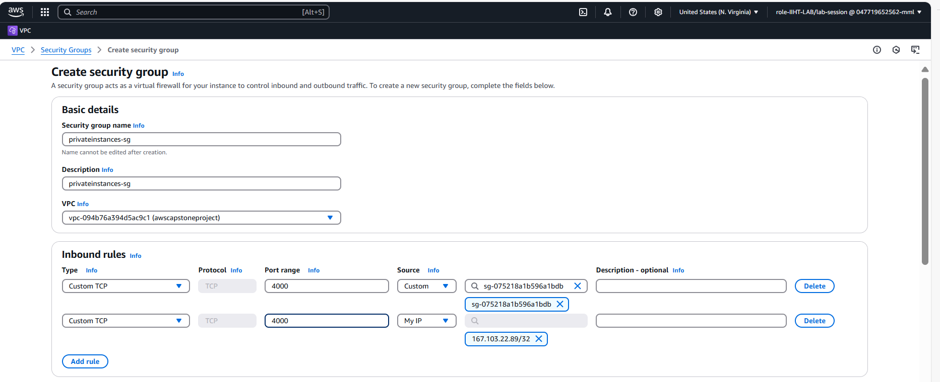

5th Security group- Access to Mysql and port 3306

Private-instances-sg

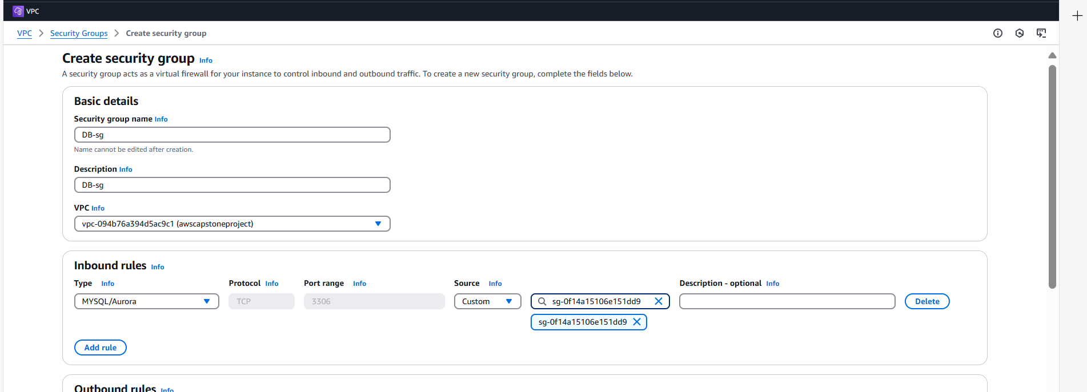

1. **DATABASE DEPLOYMENT**

**Step 1: Create a DB Subnet group.**

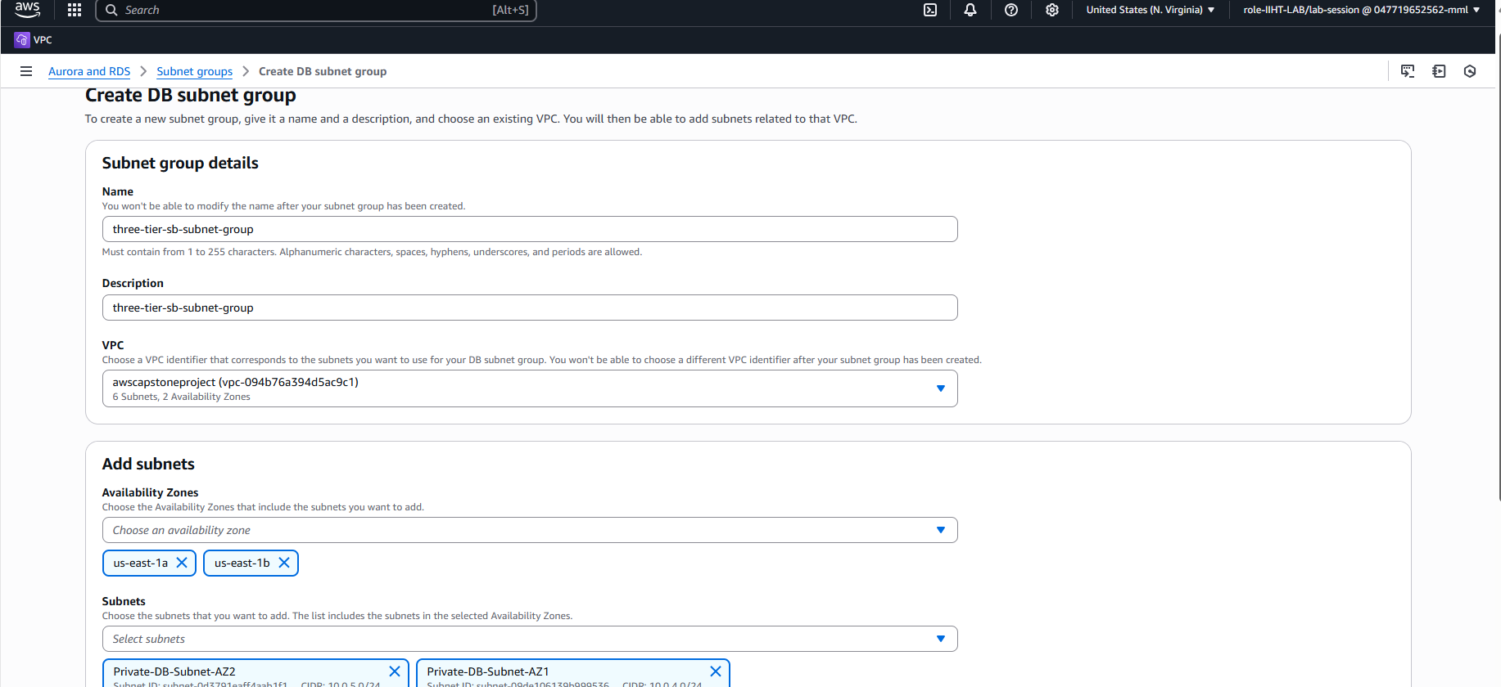

**Step 2: Goto Databases**

**Create a database.**

**Create a Master password: Adminpassword123**

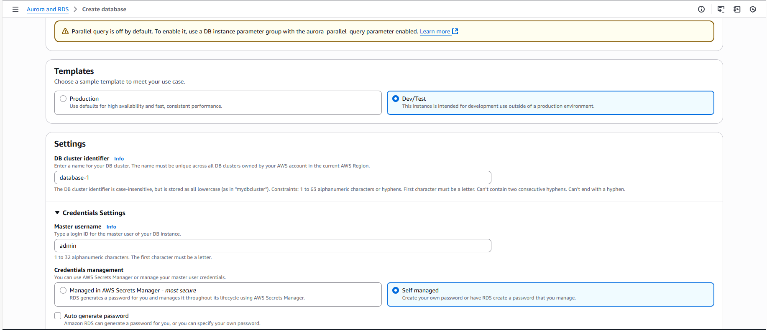

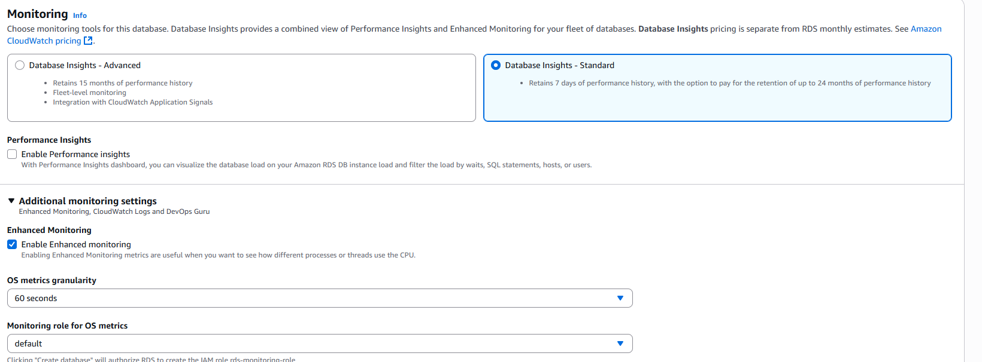

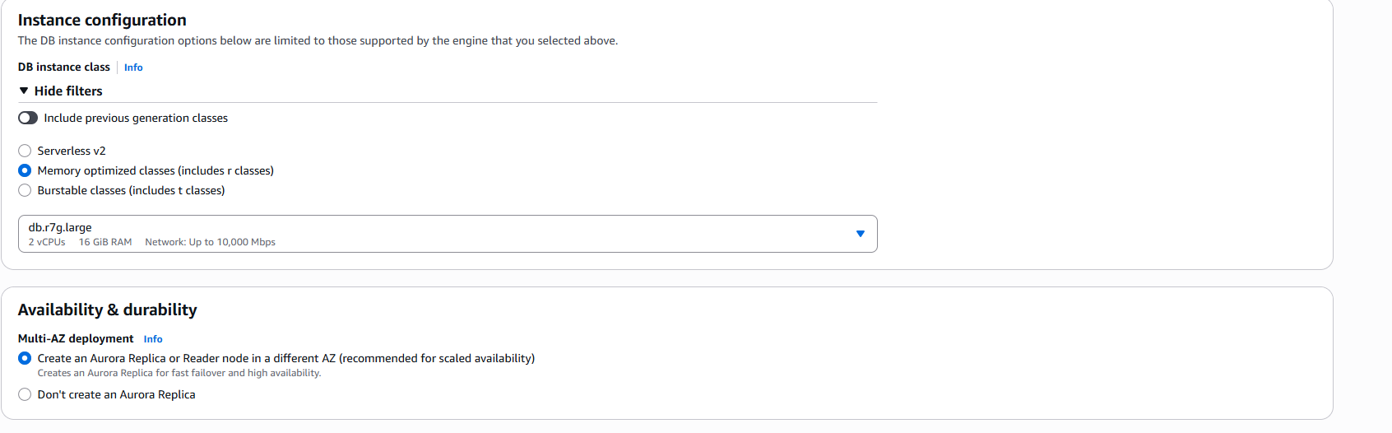

**Databases created.**

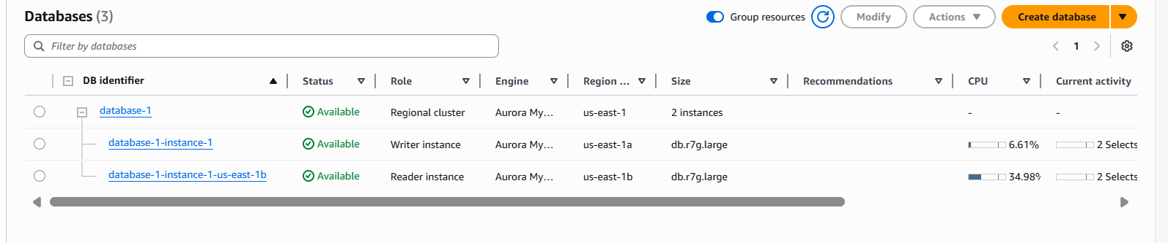

**App Tier Instance Deployment**

**Step 1: Create an EC2 Instance.**

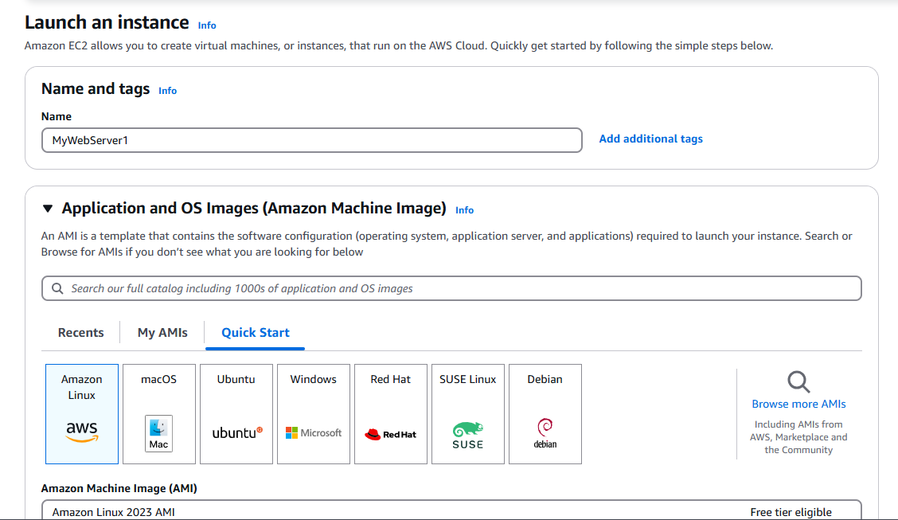

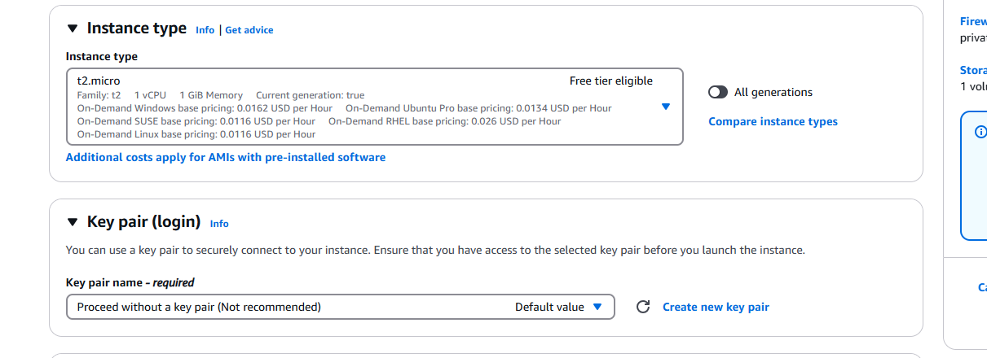

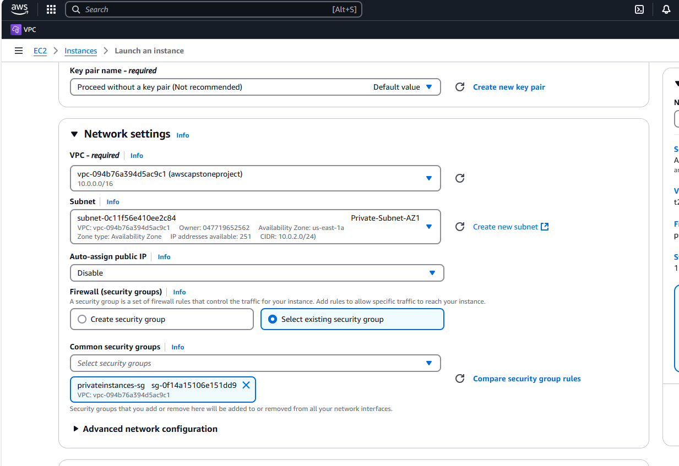

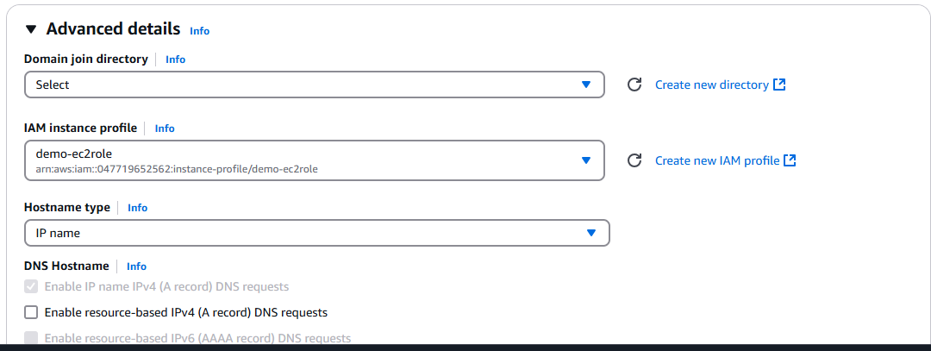

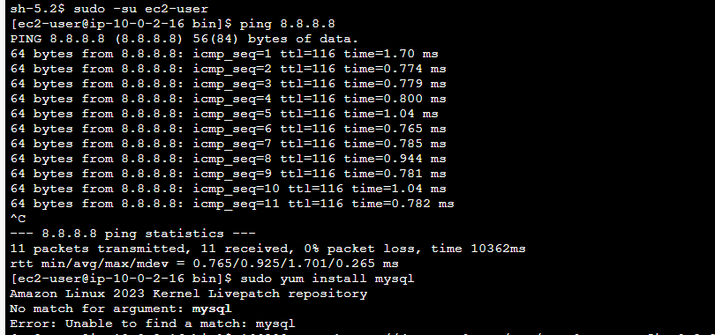

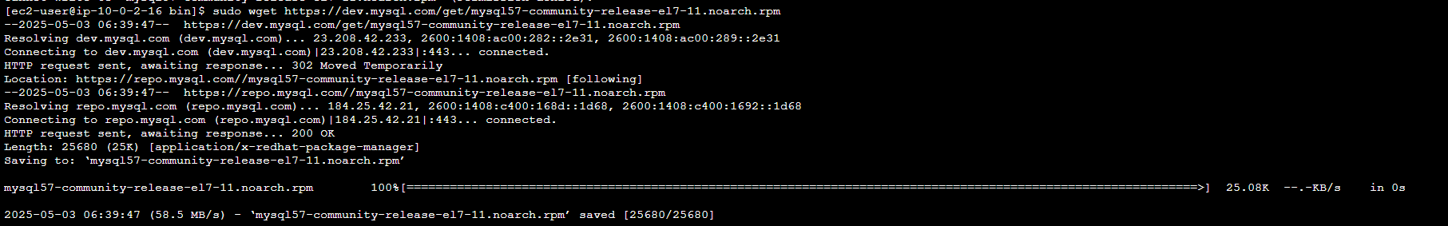

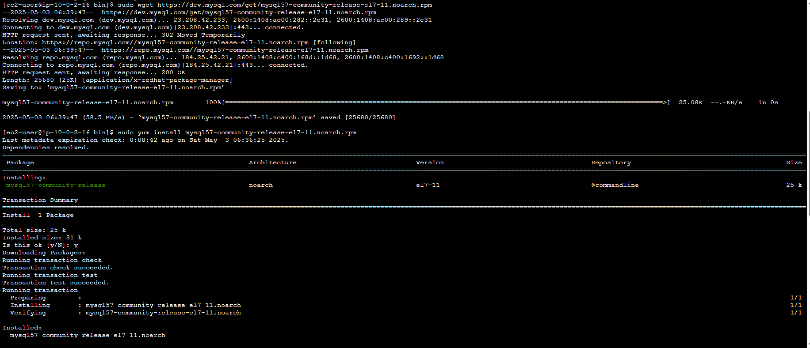



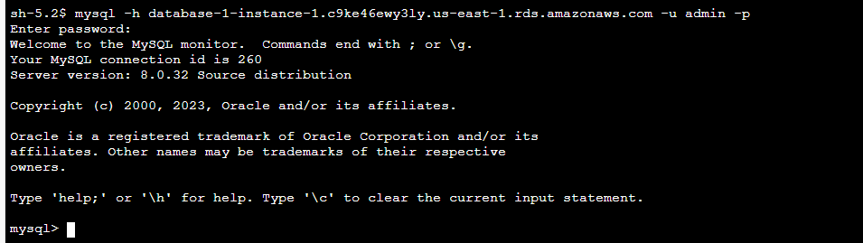

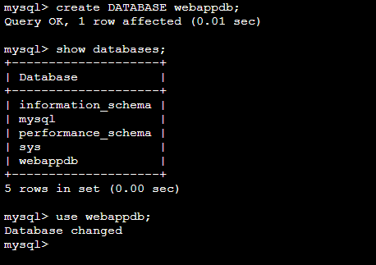

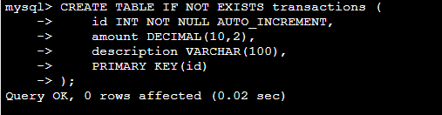

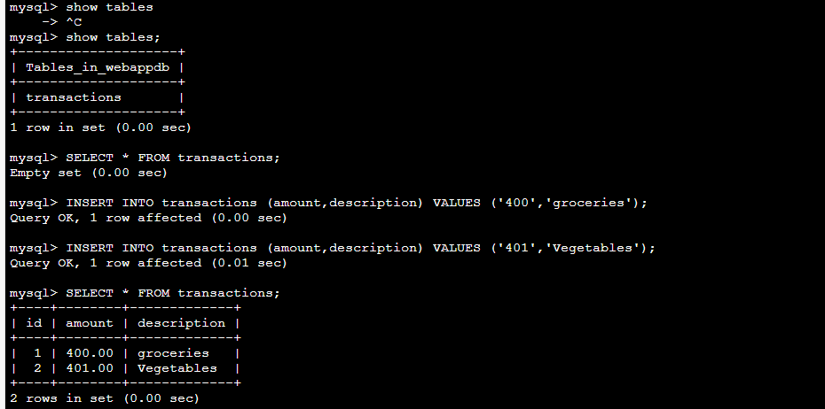

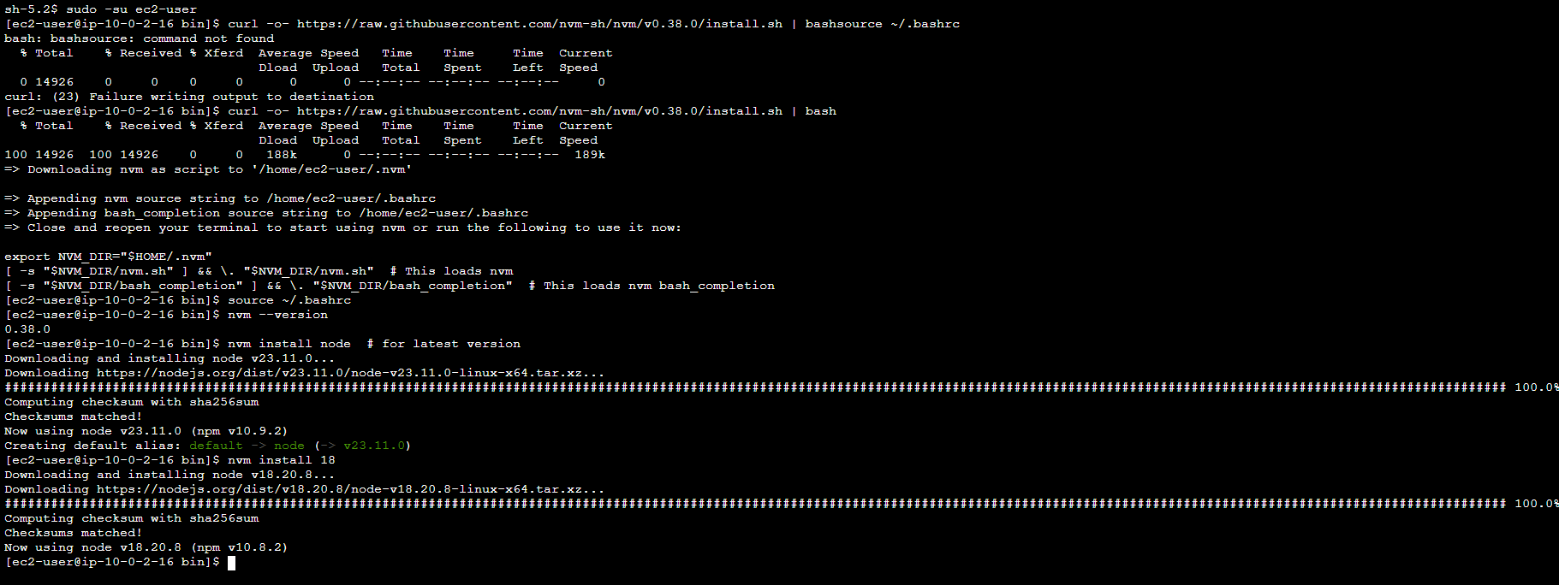

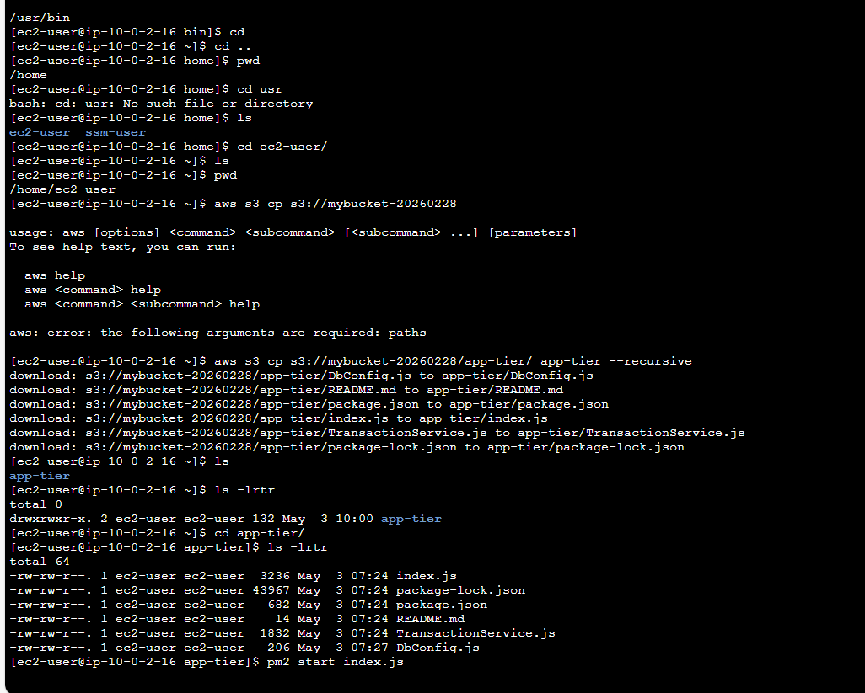

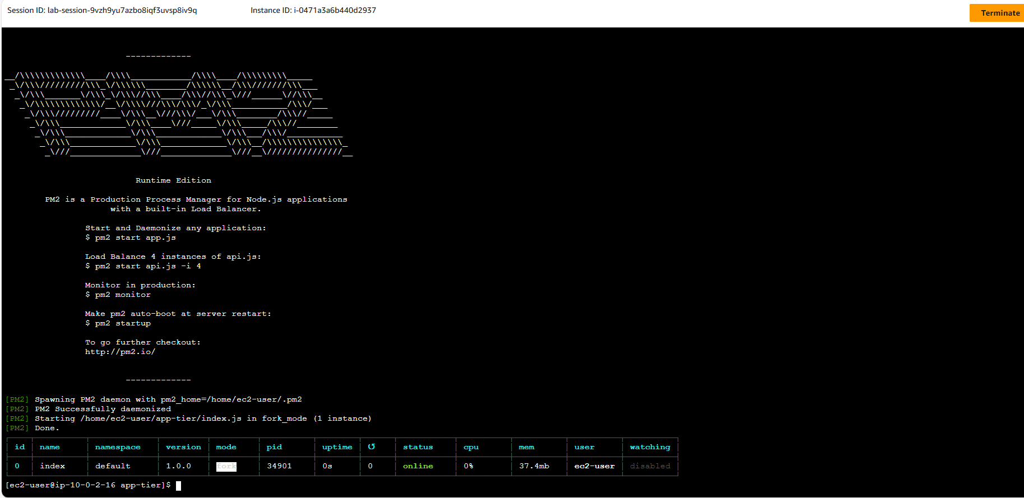

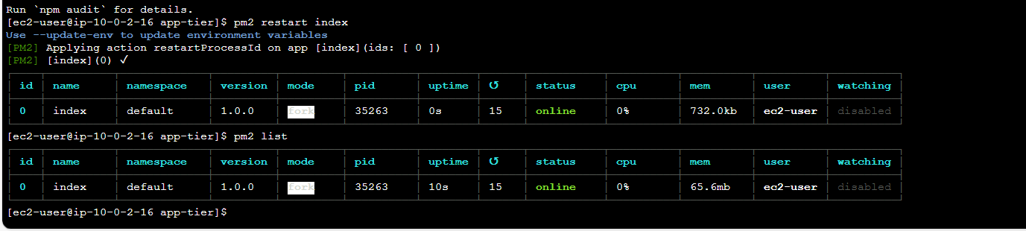

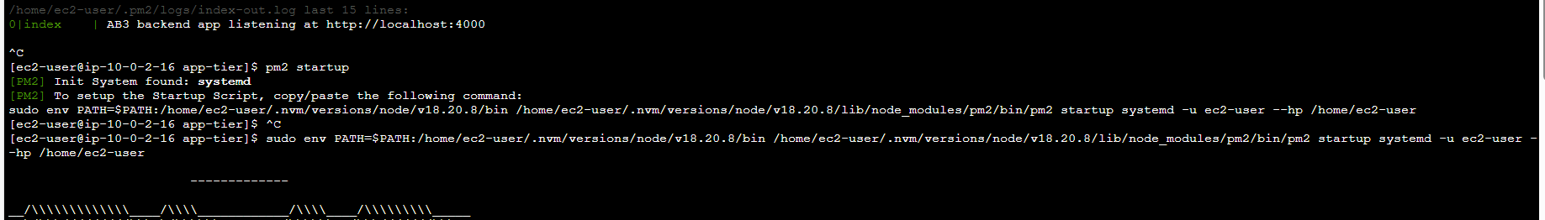

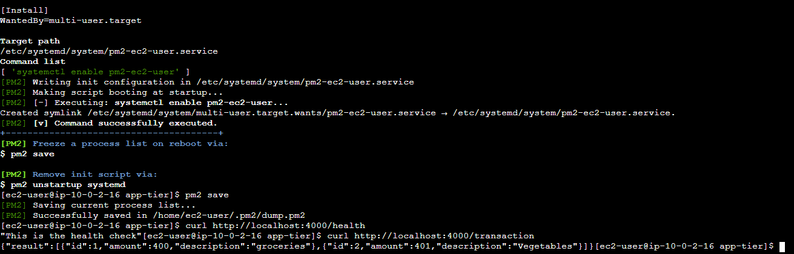

**Internal Load Balancing and Auto Scaling**

**Step 1: App Tier AMI**

**-Goto the instance created change the name as myappserver1 for the instance.**

**- Select the instance>Actions>Create image.**

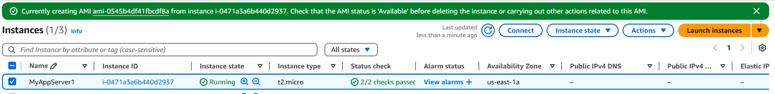

**Step 2: Target Group**

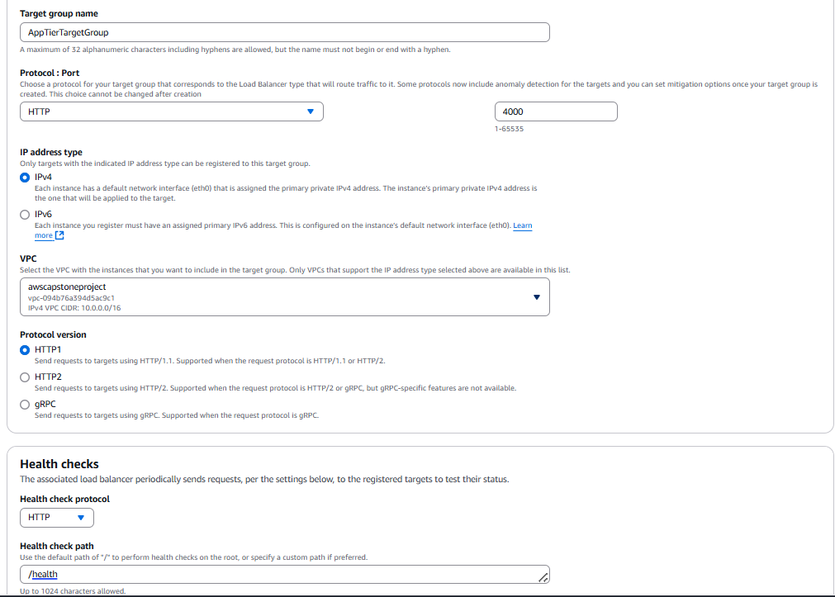

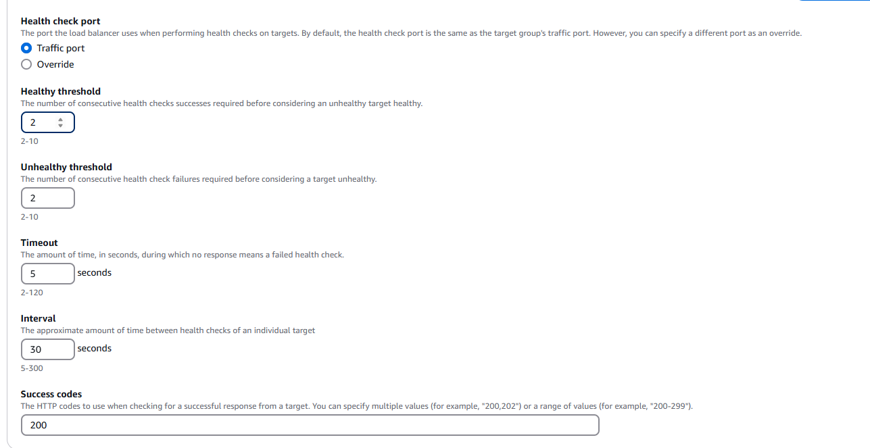

**Step 3: Internal Load Balancer**

**-Launch Template**

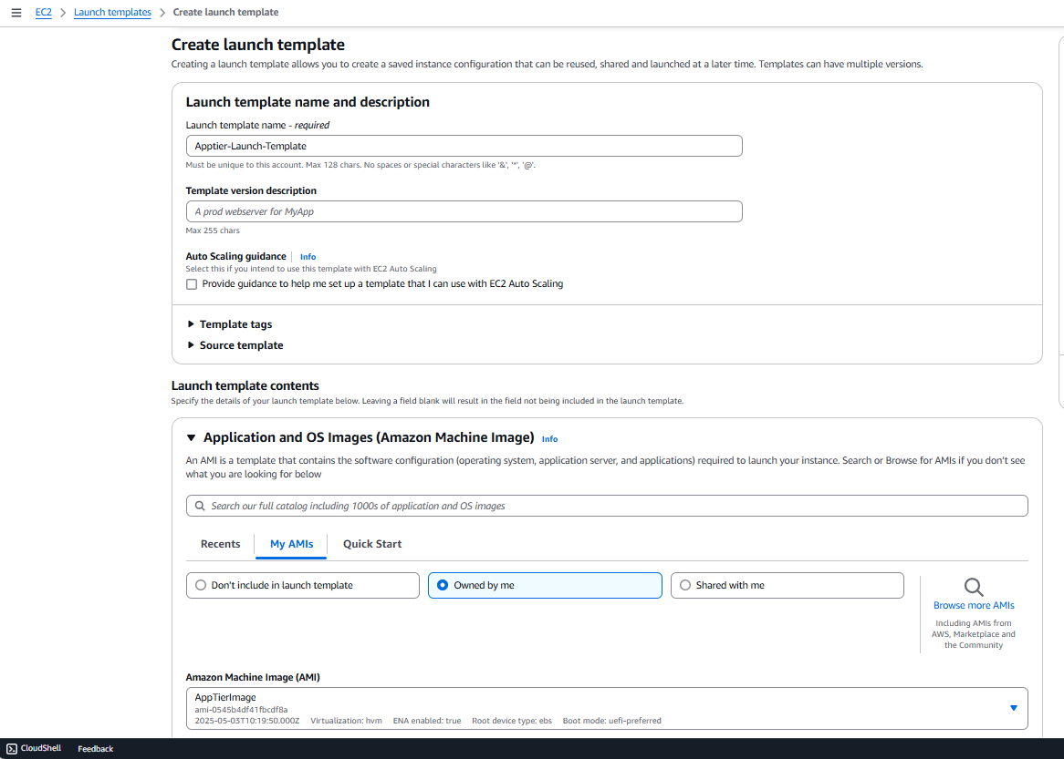

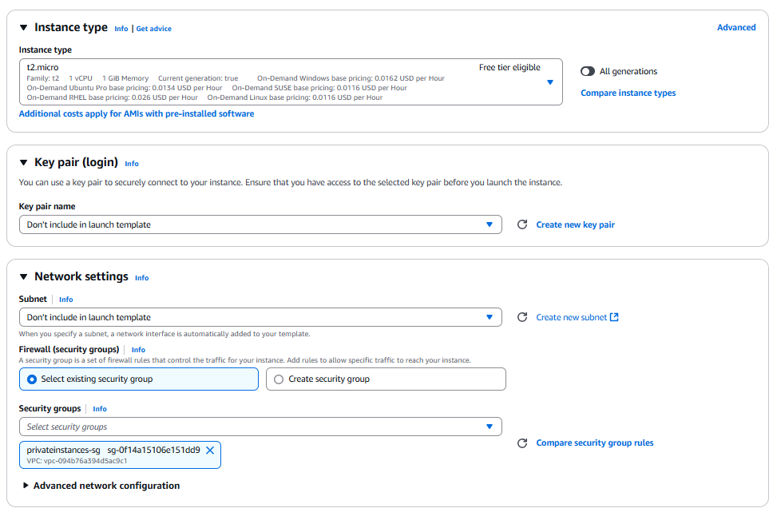

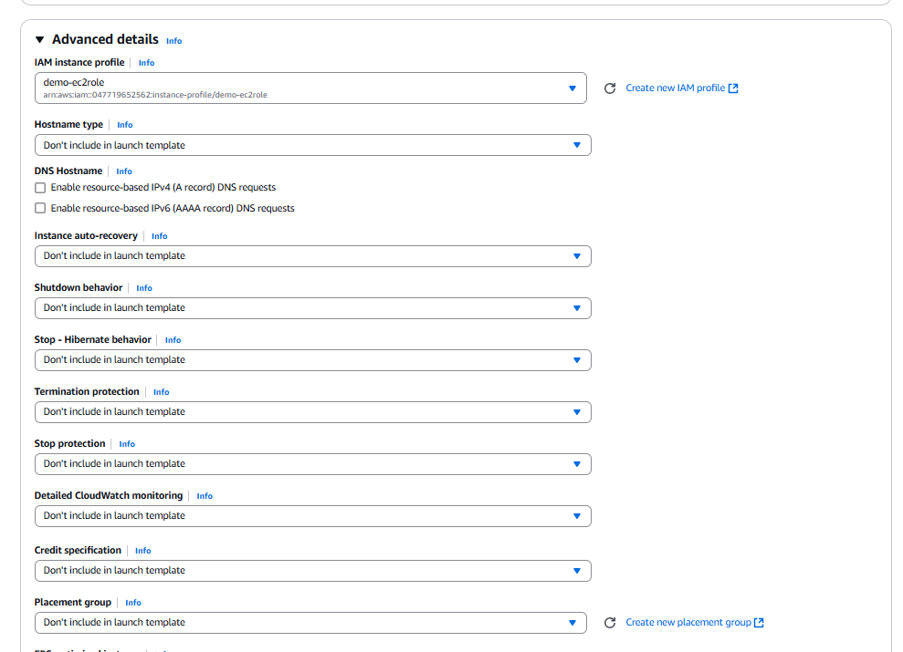

**Step 4: Auto Scaling**

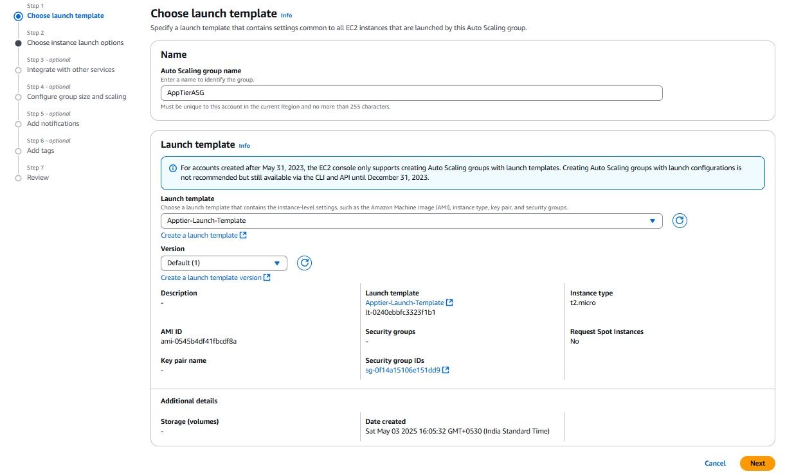

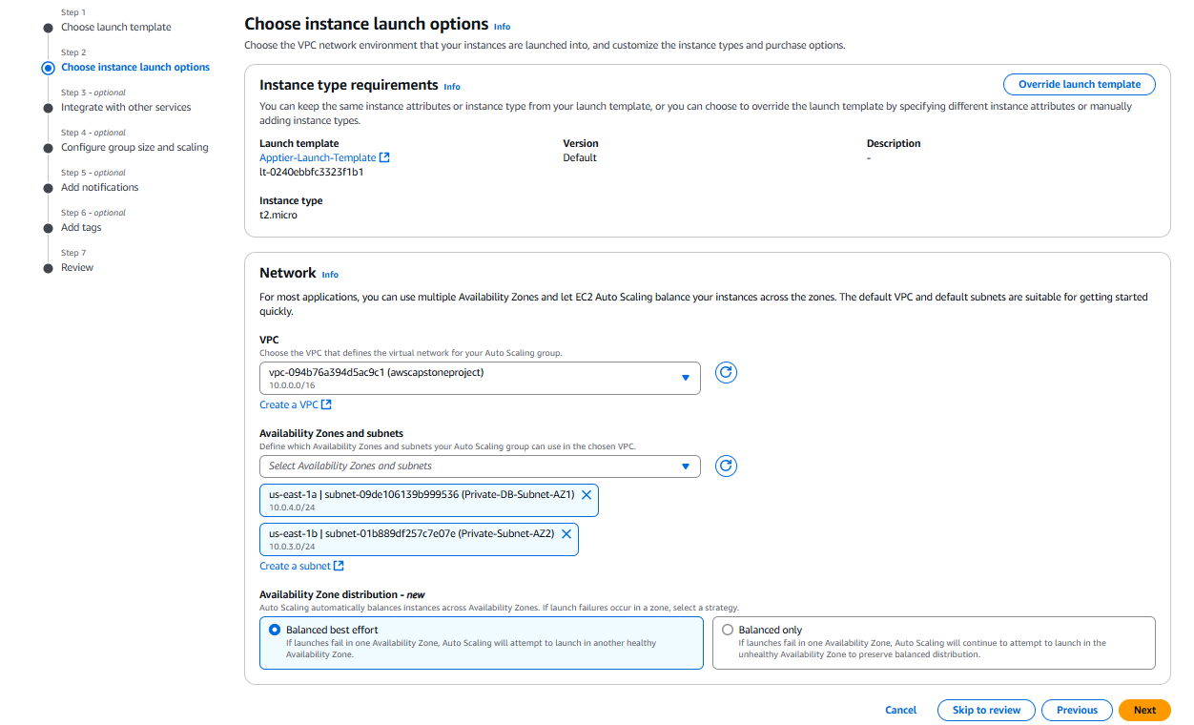

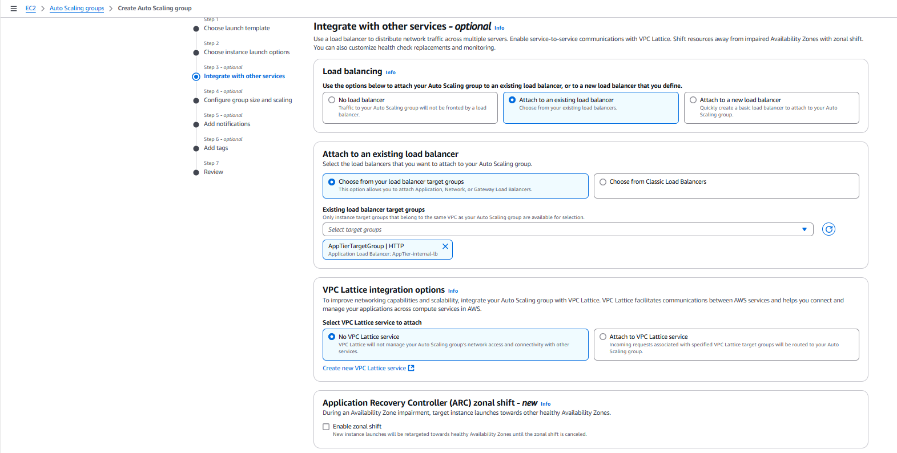

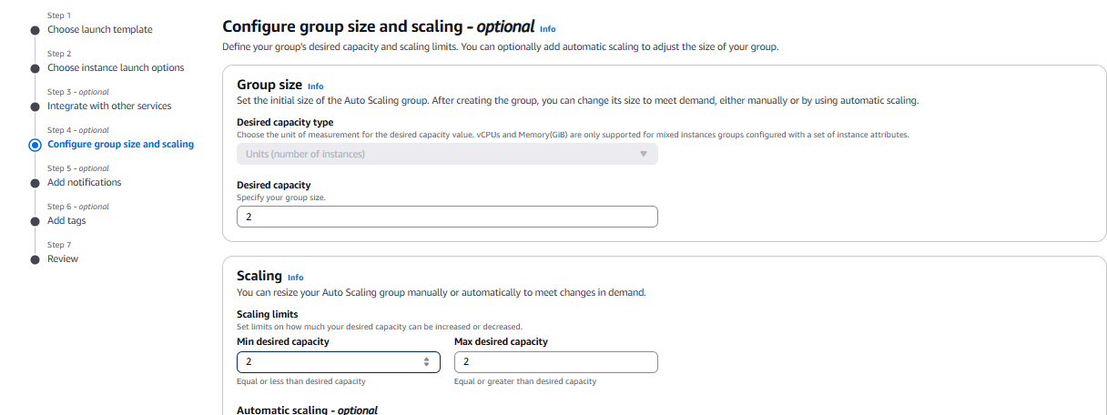

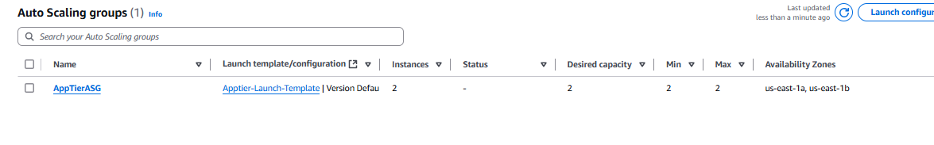

1. **Web Tier Instance Deployment**

**Step 1: Update Config File.**

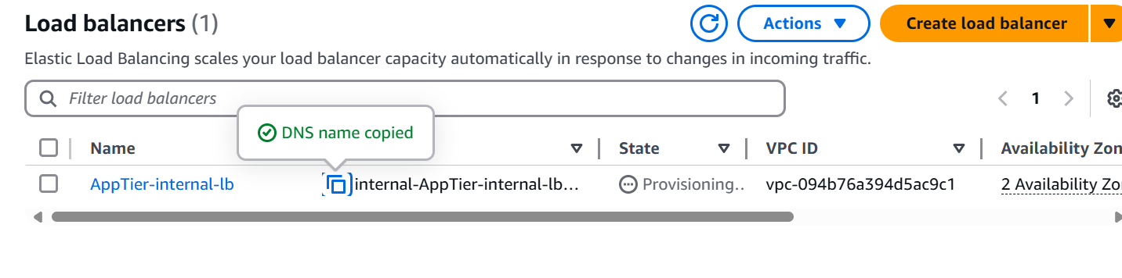

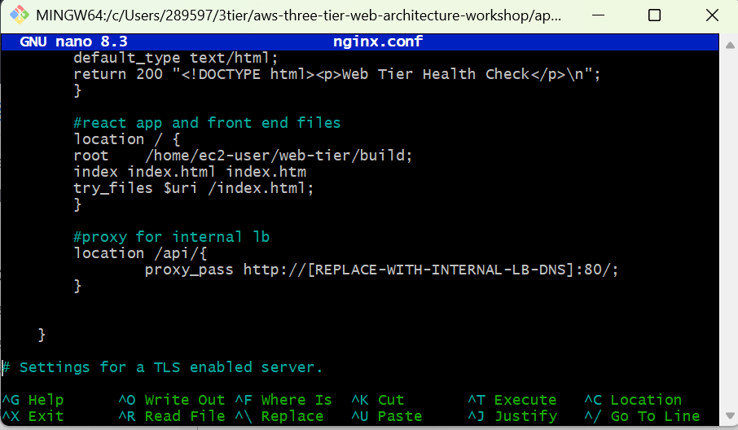

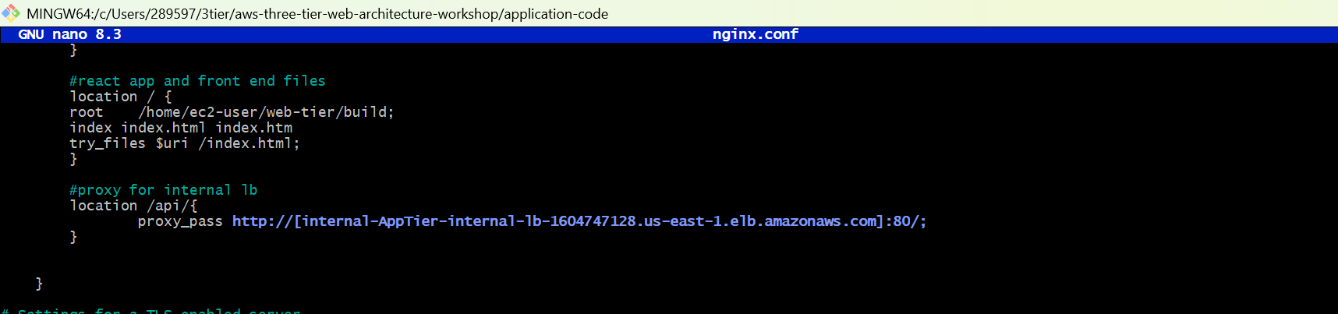

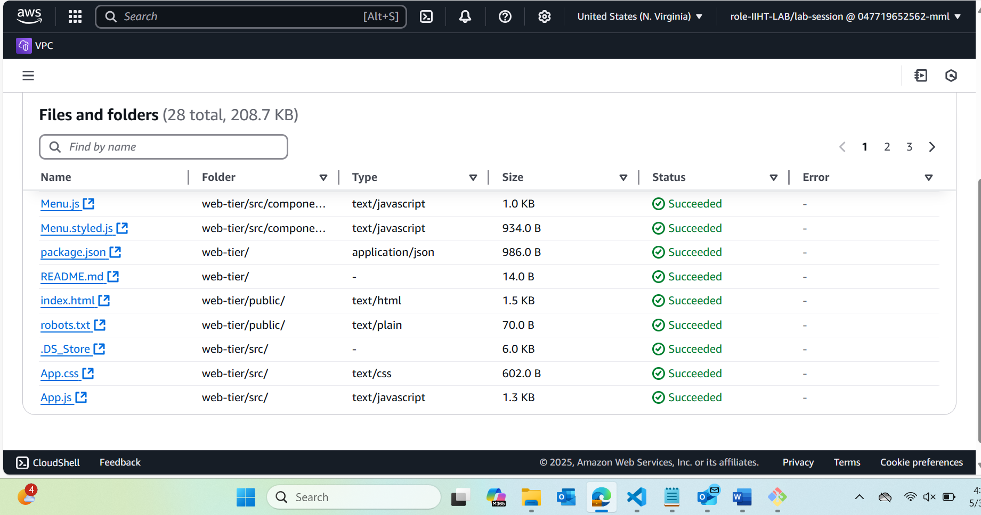

**-**upload all the webtier and nginx.conf file after editing the DNS in the nginx.conf file.

**Step 2: Web Instance Deployment.**

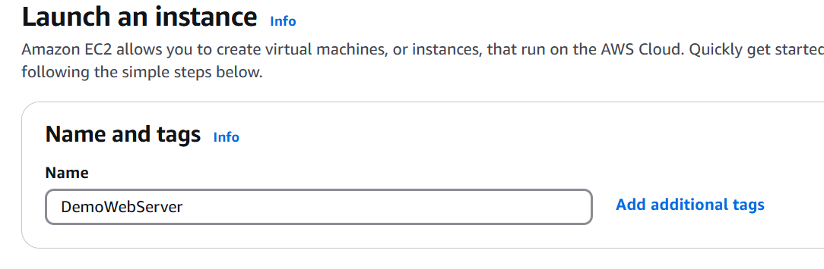

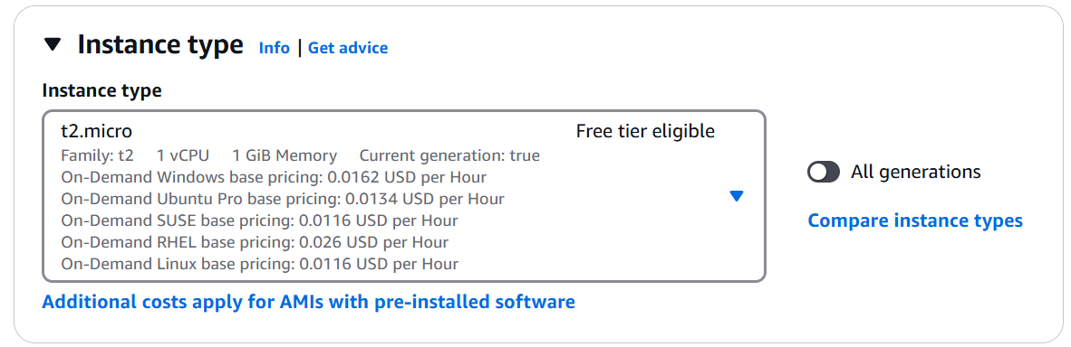

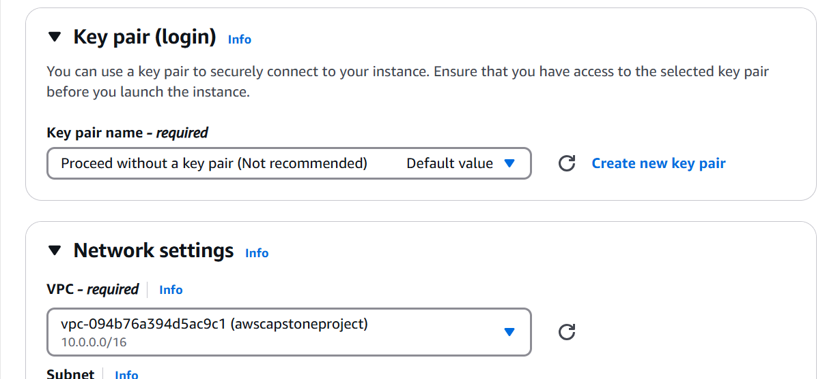

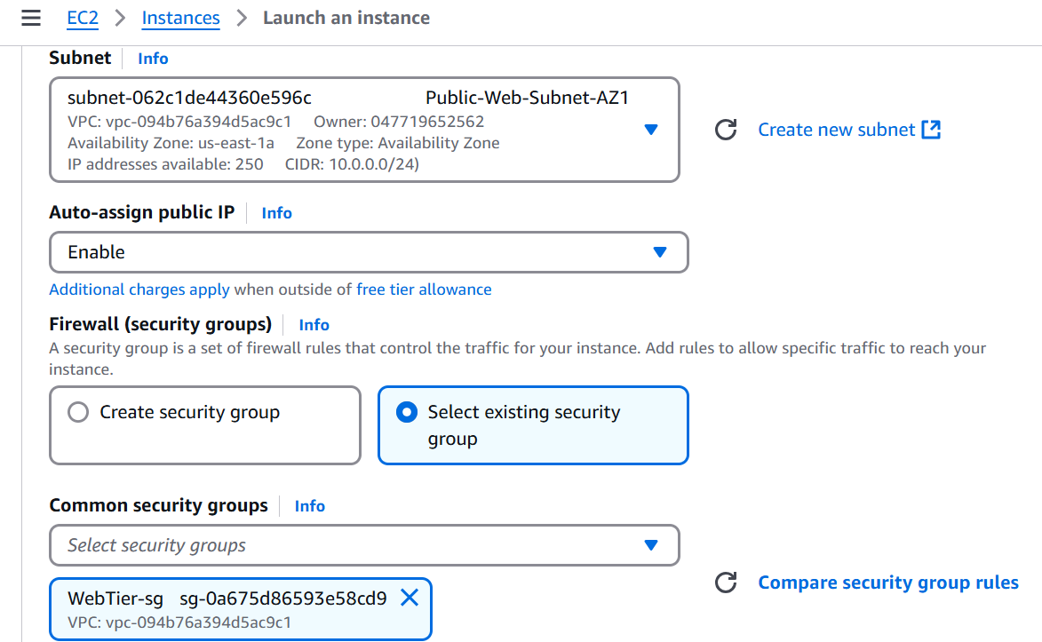

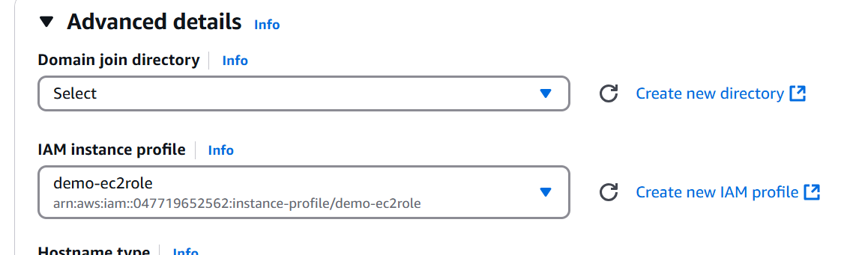

**Step 3: Connect to Instance.**

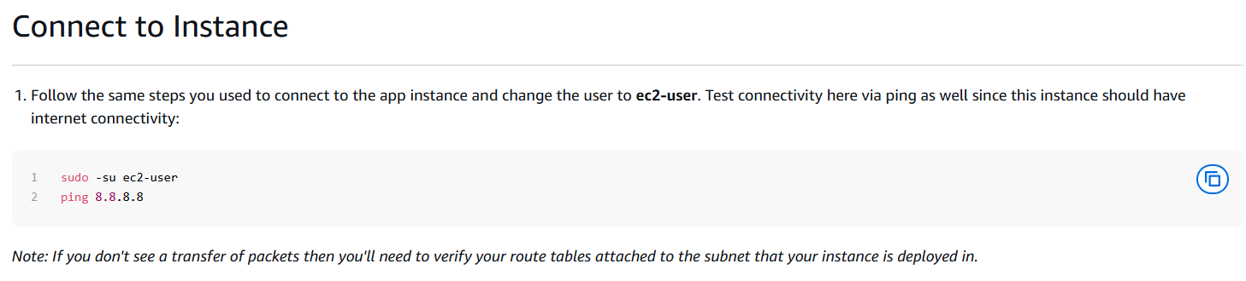

**Step 4: Configure Web Instance**

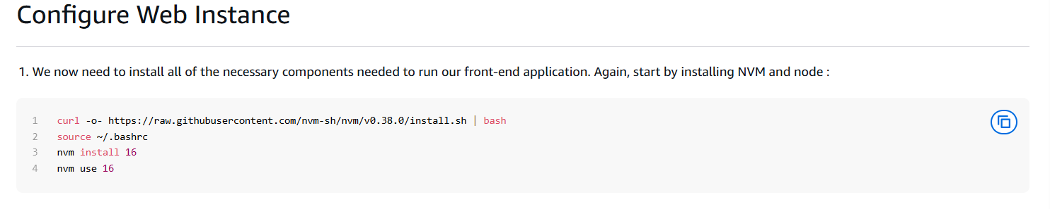

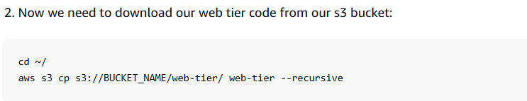

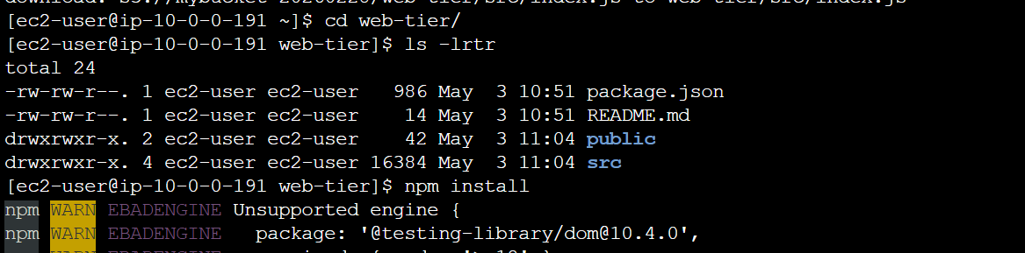

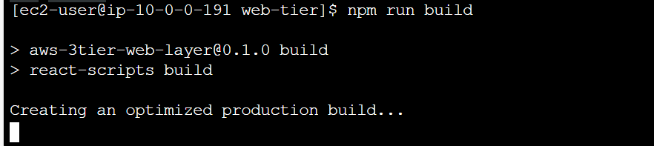



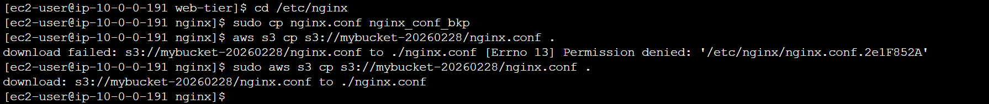

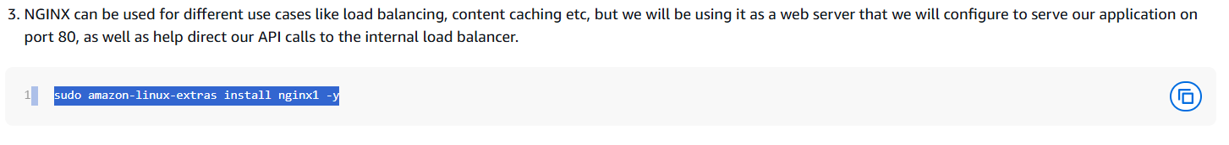

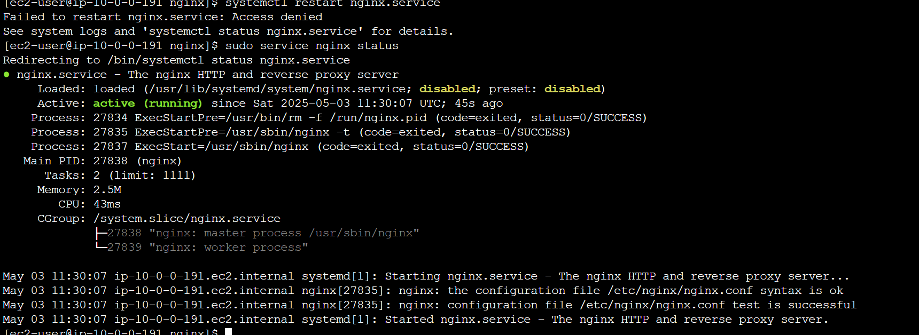



1. **External Load Balancer and Auto Scaling**

**Step 1: Web Tier AMI**

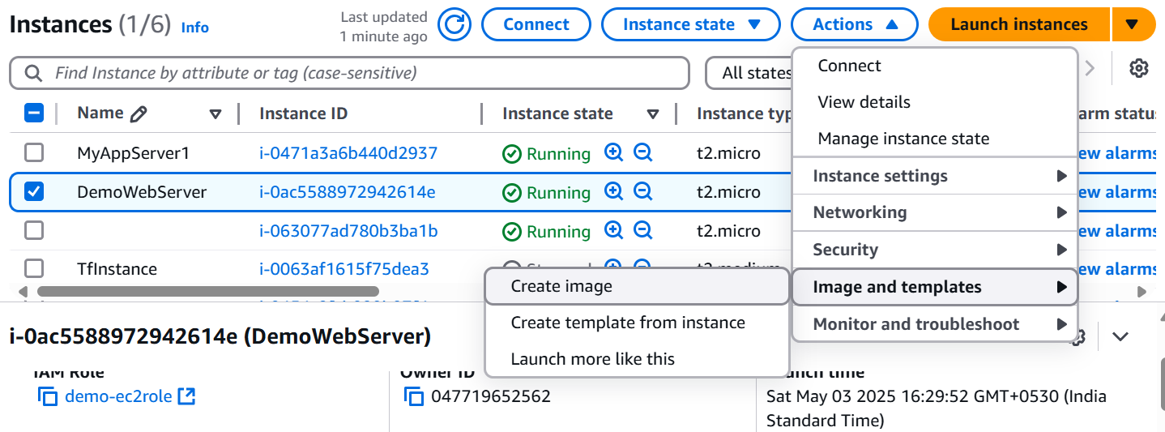

**Step 2: Target Group**

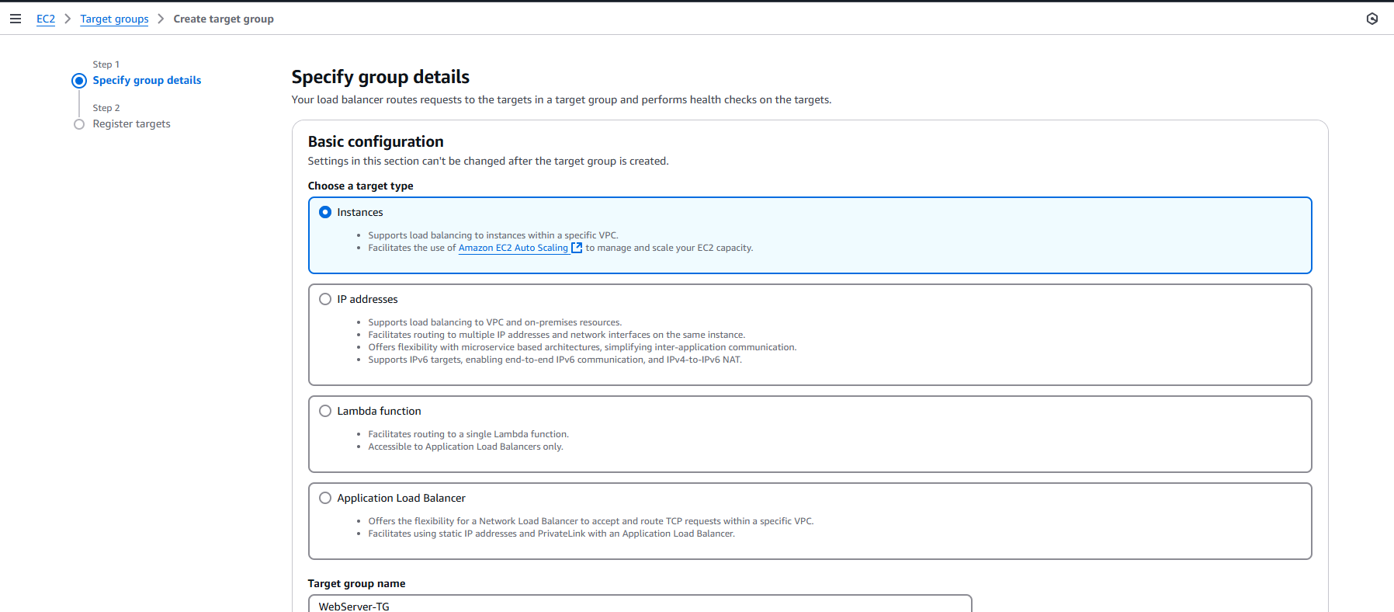

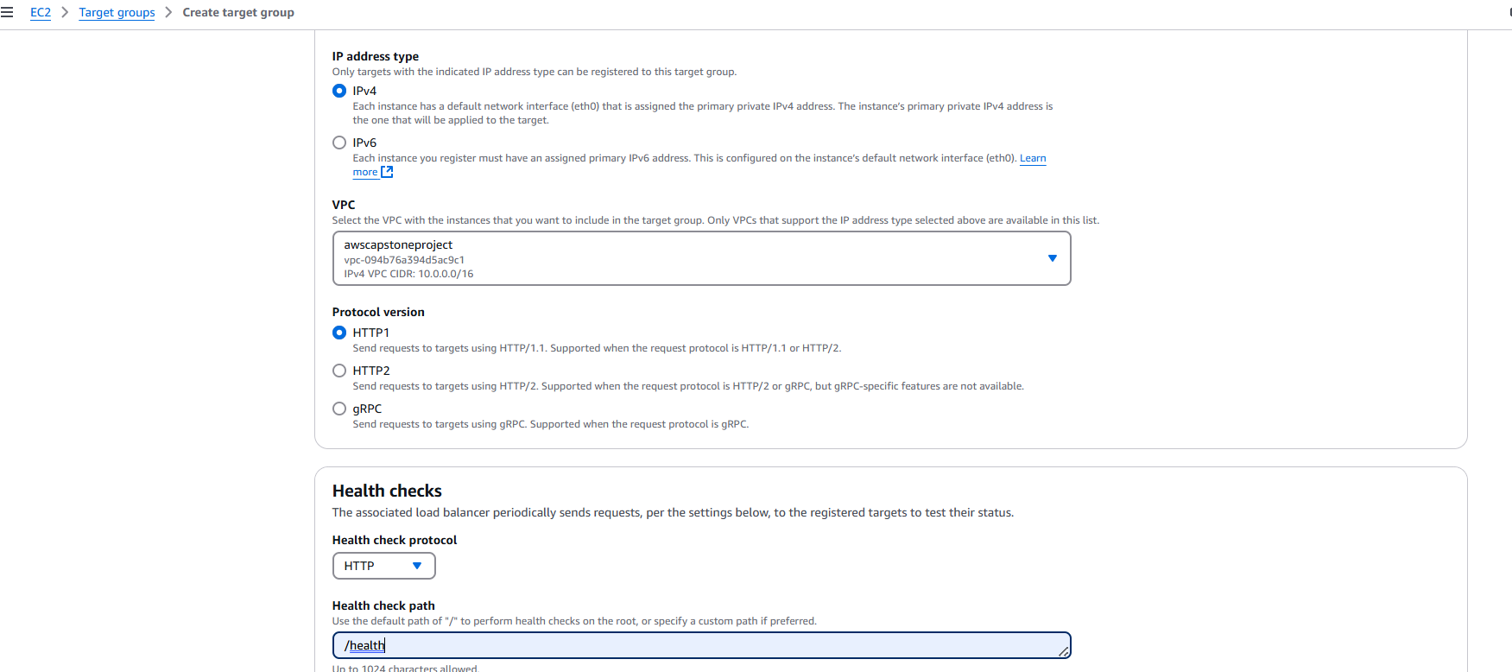

**Step 3: Internet Facing Load Balancer.**

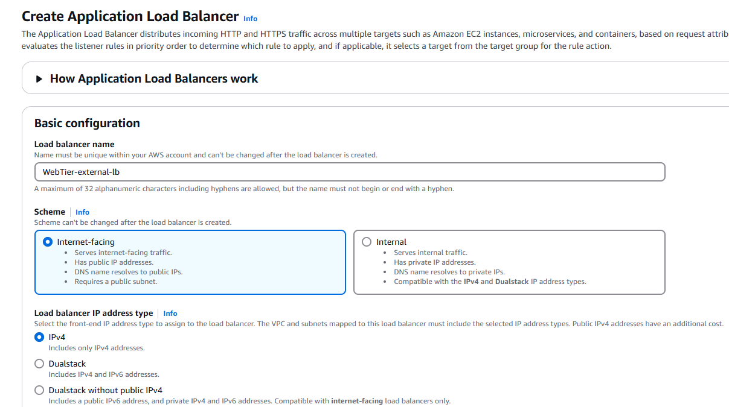

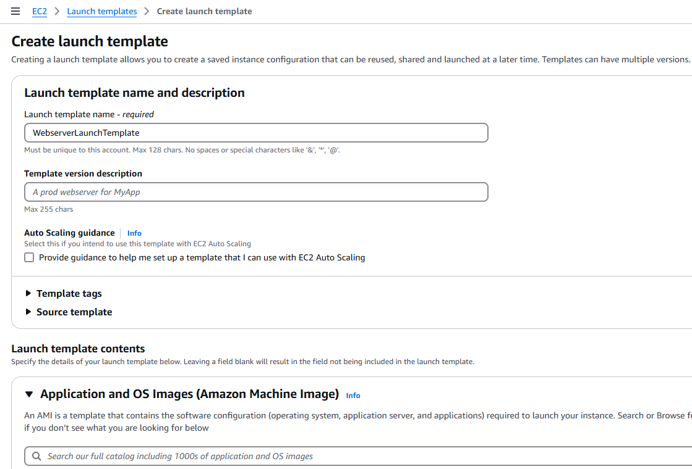

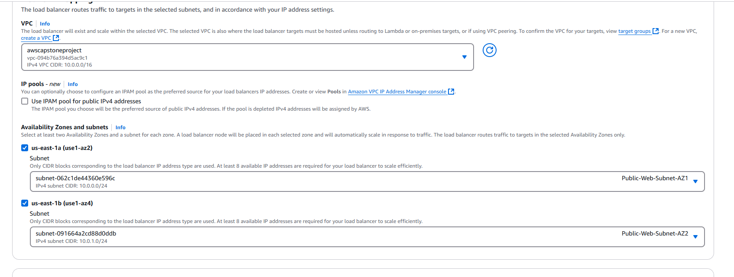

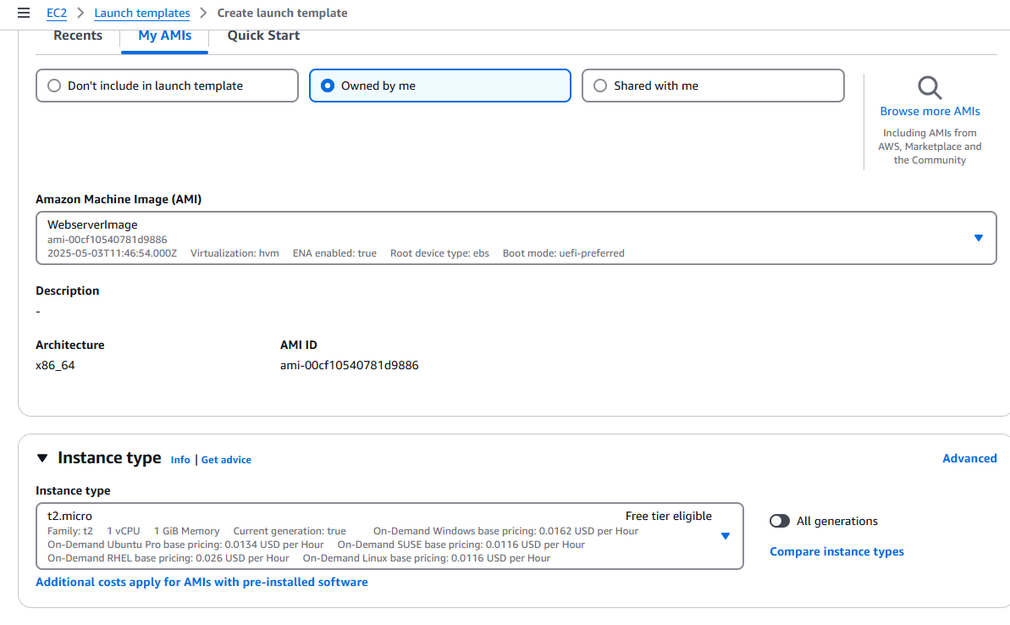

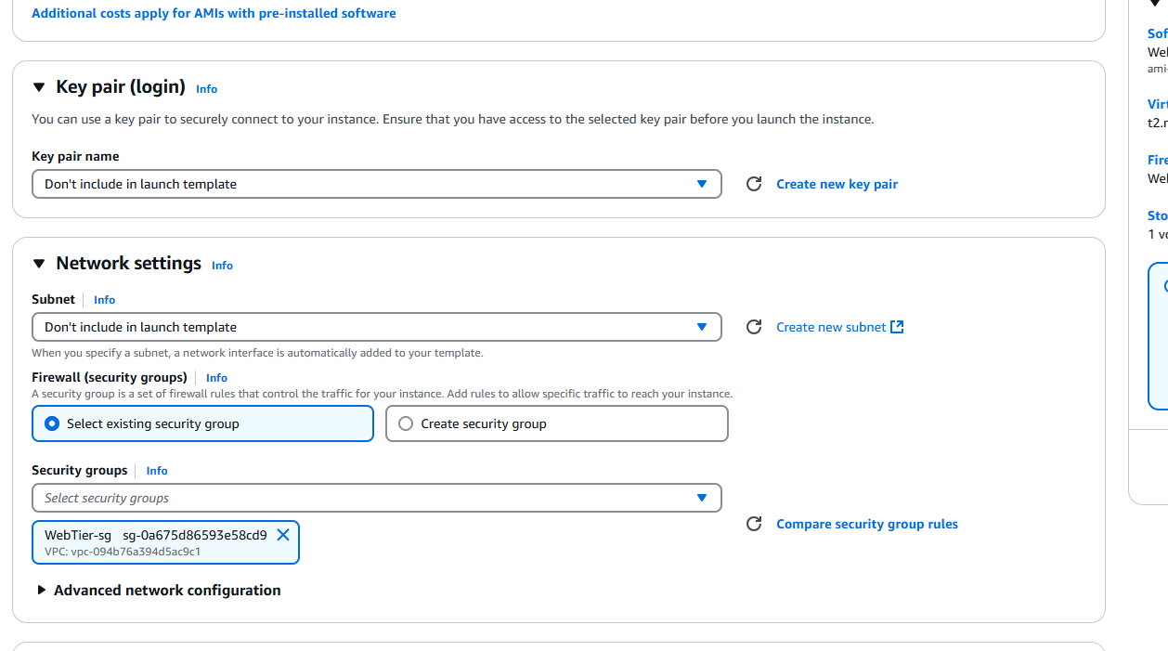

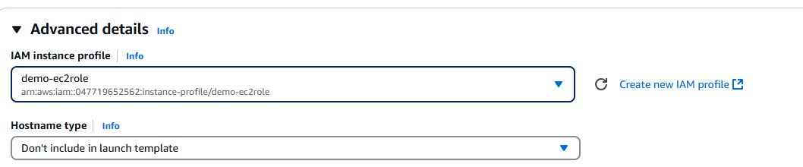

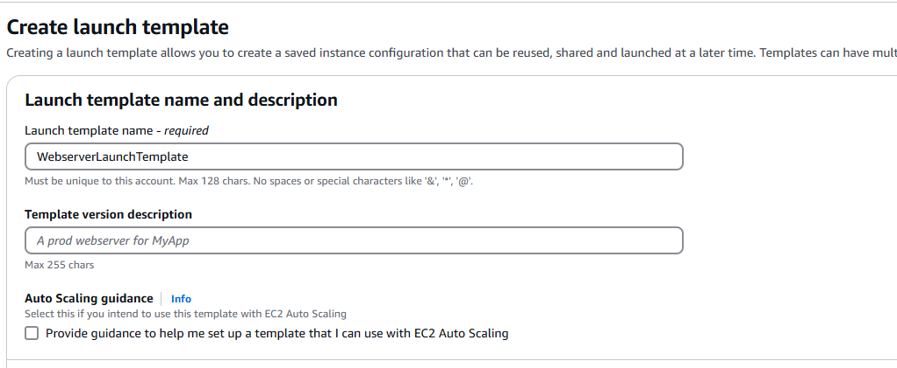

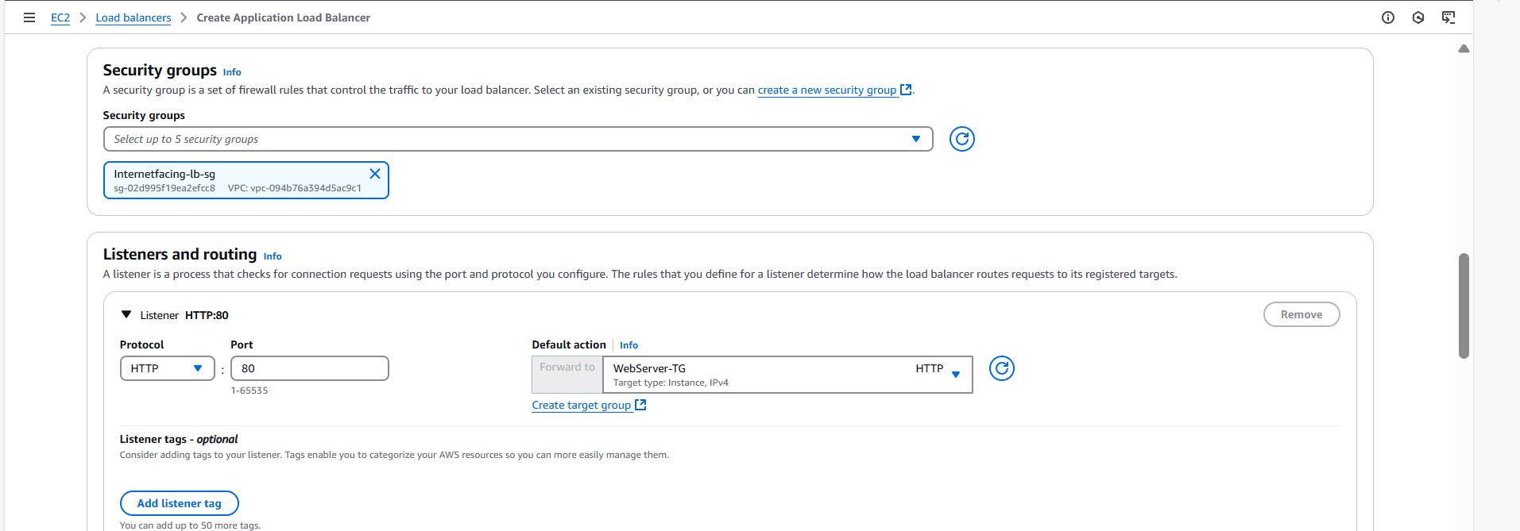

**Create AutoScaling group**

